Lab 6

### CMPSC 443

**Pre task**

We have installed the http header live

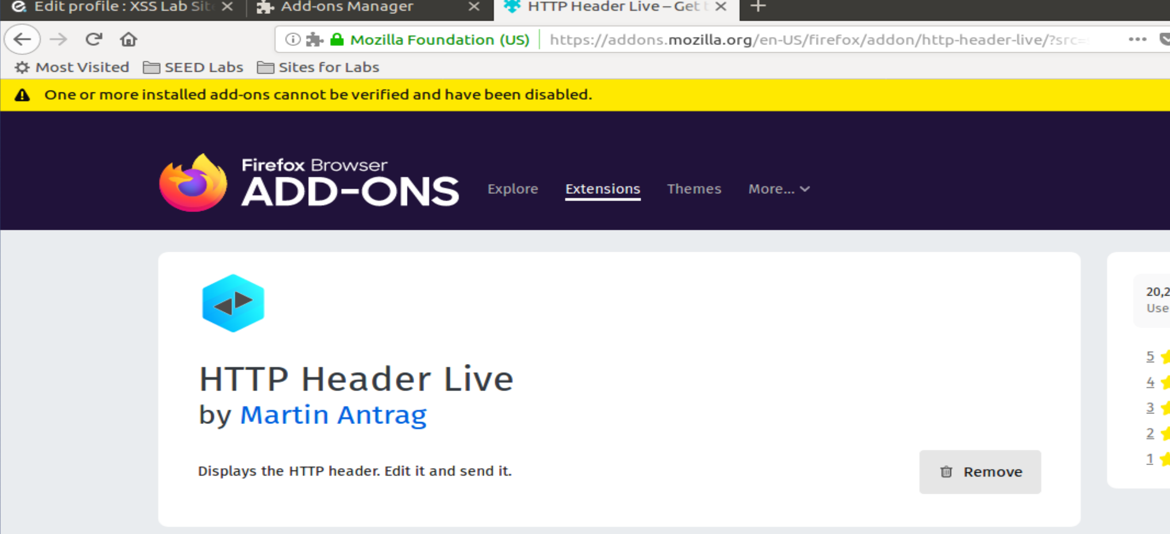

**Task 1: Posting a Malicious Message to Display an Alert Window**

We will put the alert in the brief description

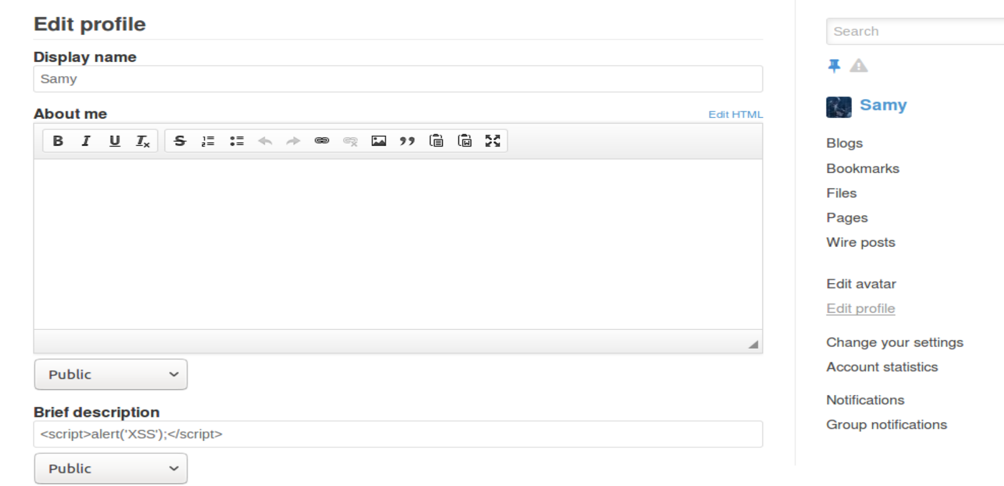

And we can see the pop up window when we enter the profile of sammy

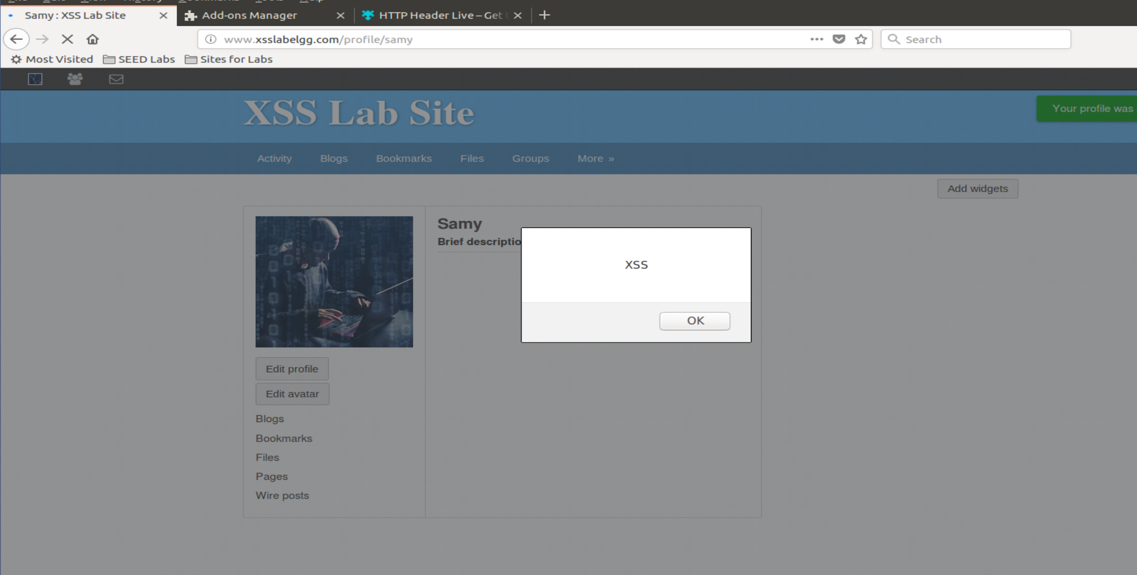

**Task 2: Posting a Malicious Message to Display Cookies**

We will insert the new alert instead of the XSS alert

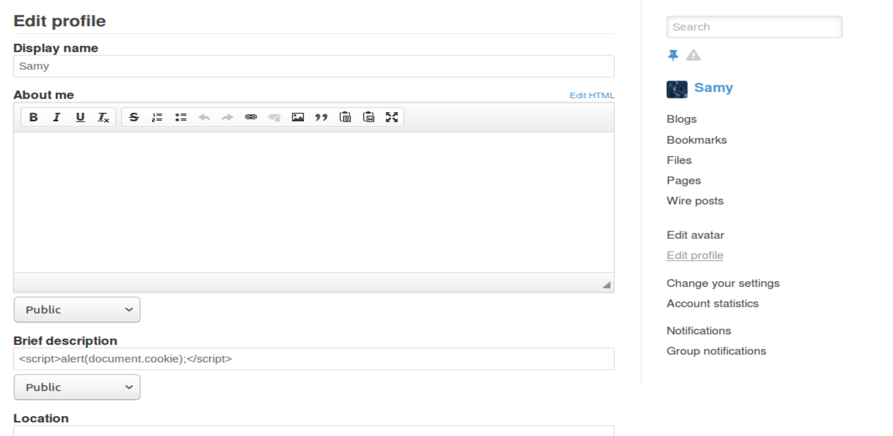

The result:

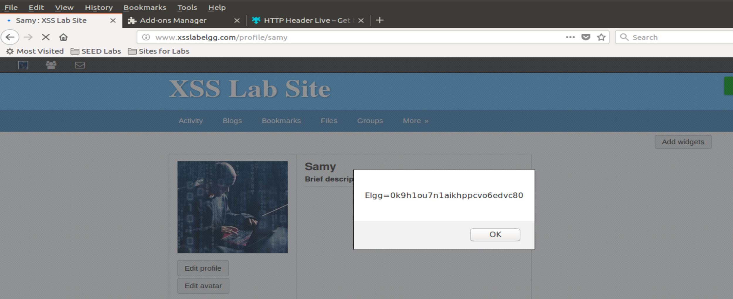

**Task 3: Stealing Cookies from the Victim’s Machine**

**One VM**

We will first get our ip address

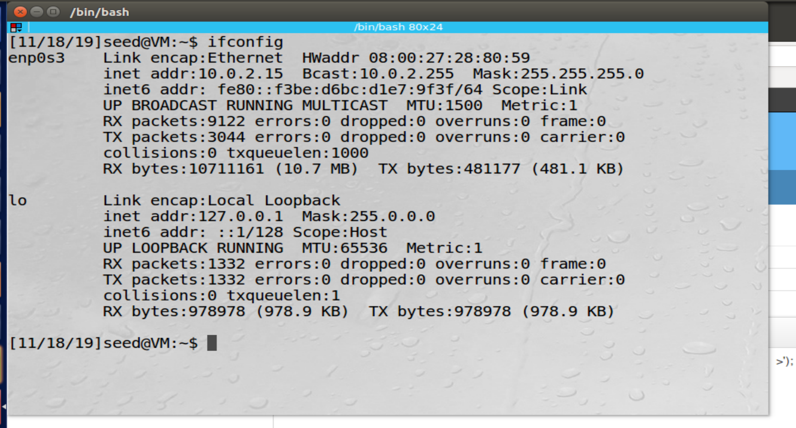

Now we will insert the code into the profile

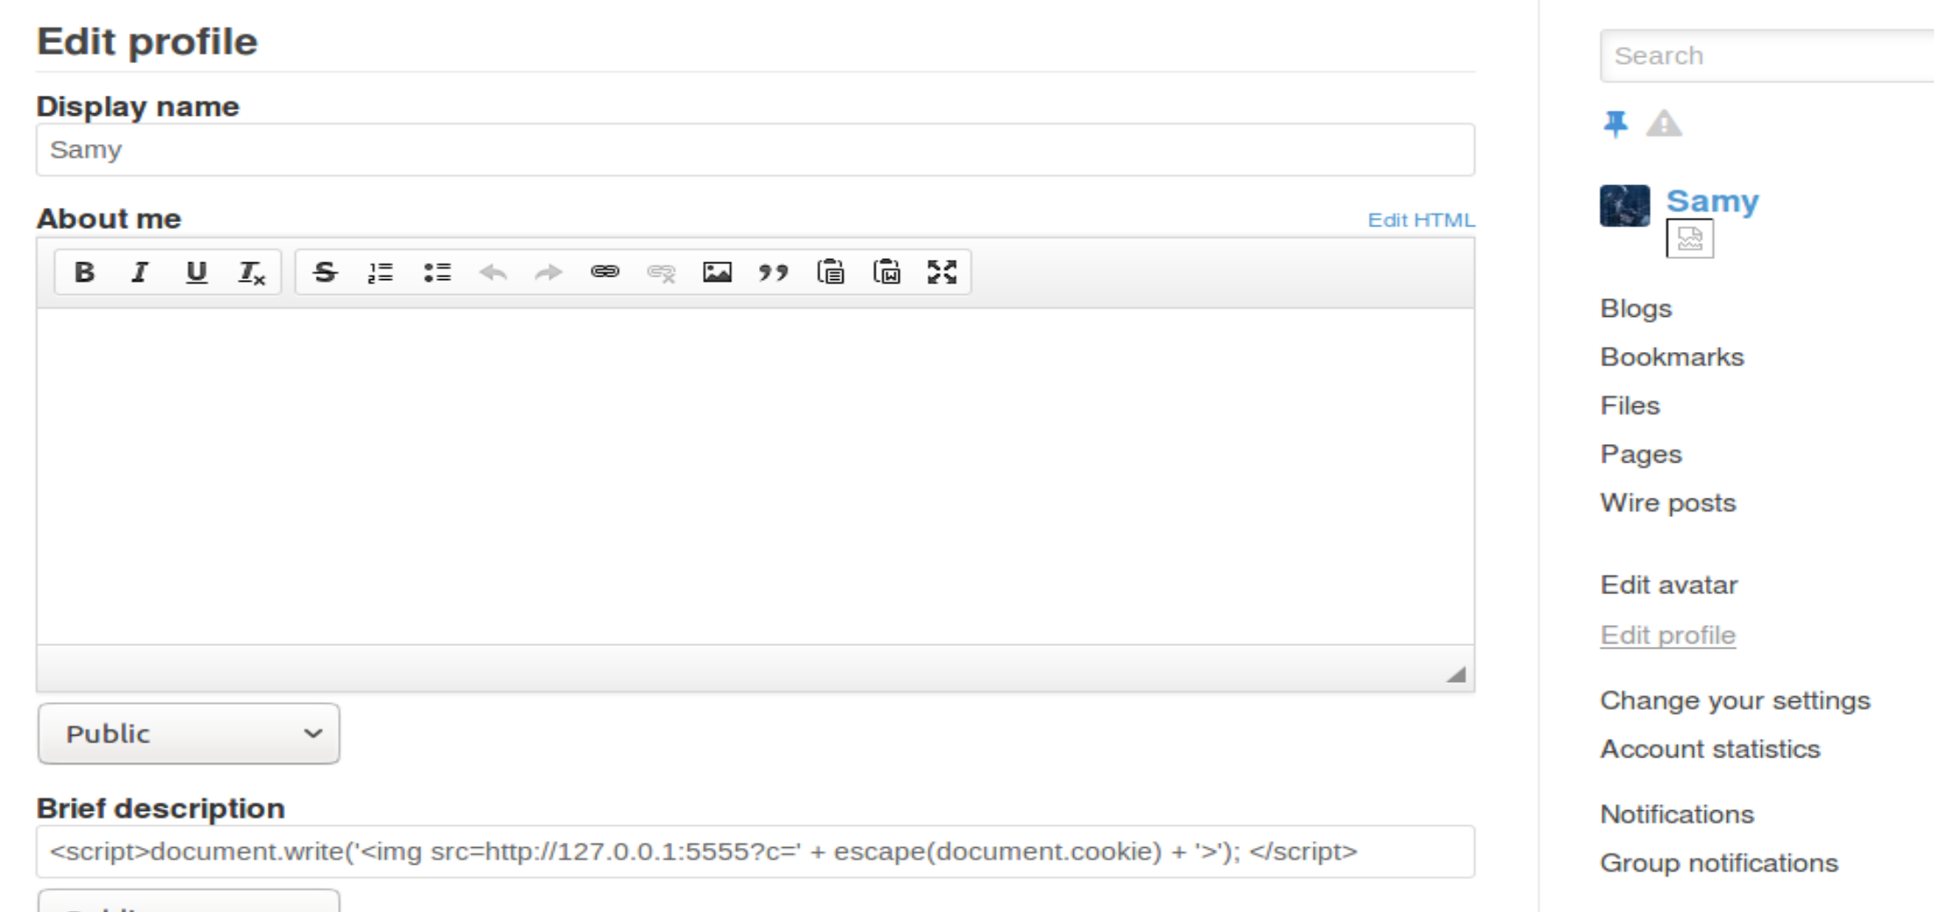

And our terminal with the nc command

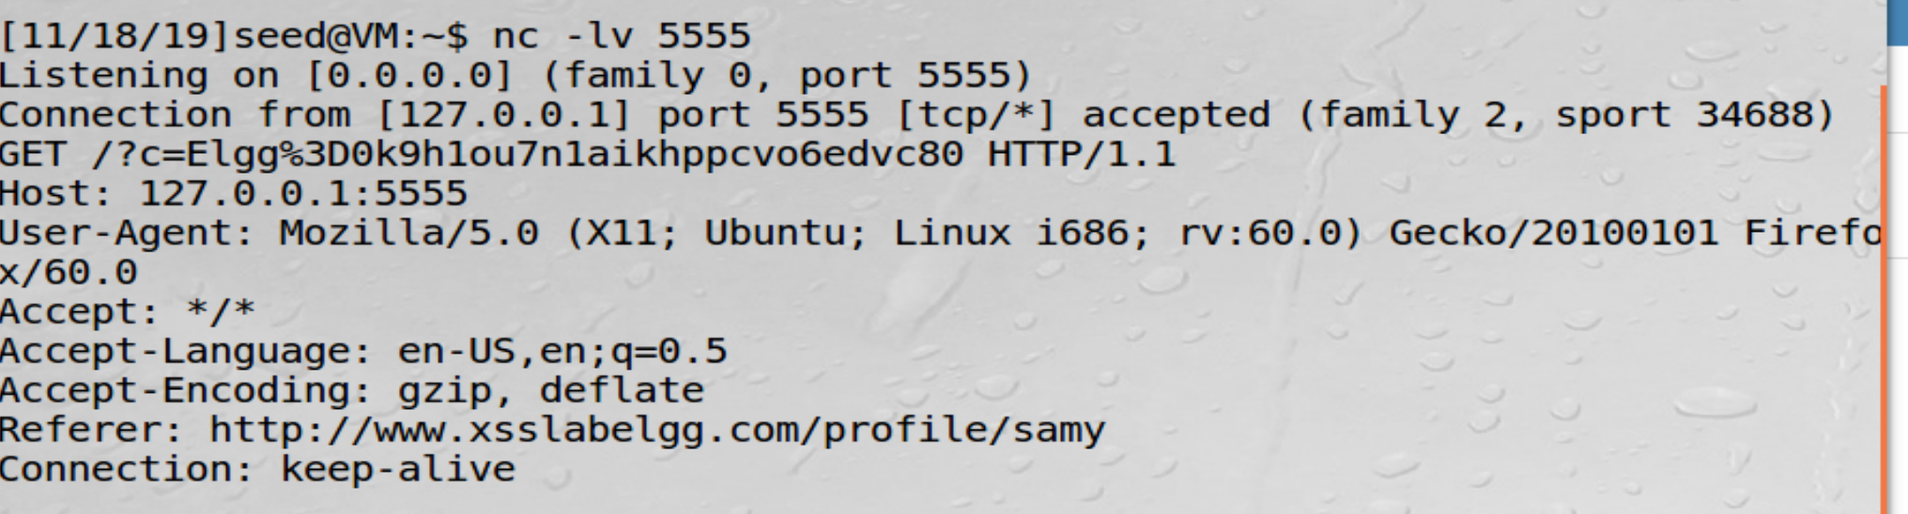

We got the same cookie now

**Task 4: Becoming the Victim’s Friend**

We will enter as boby and add samy as a friend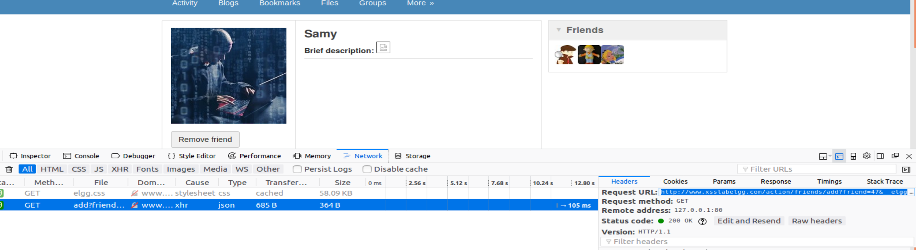

We will take the address and use it in our code (inside EDIT HTML)

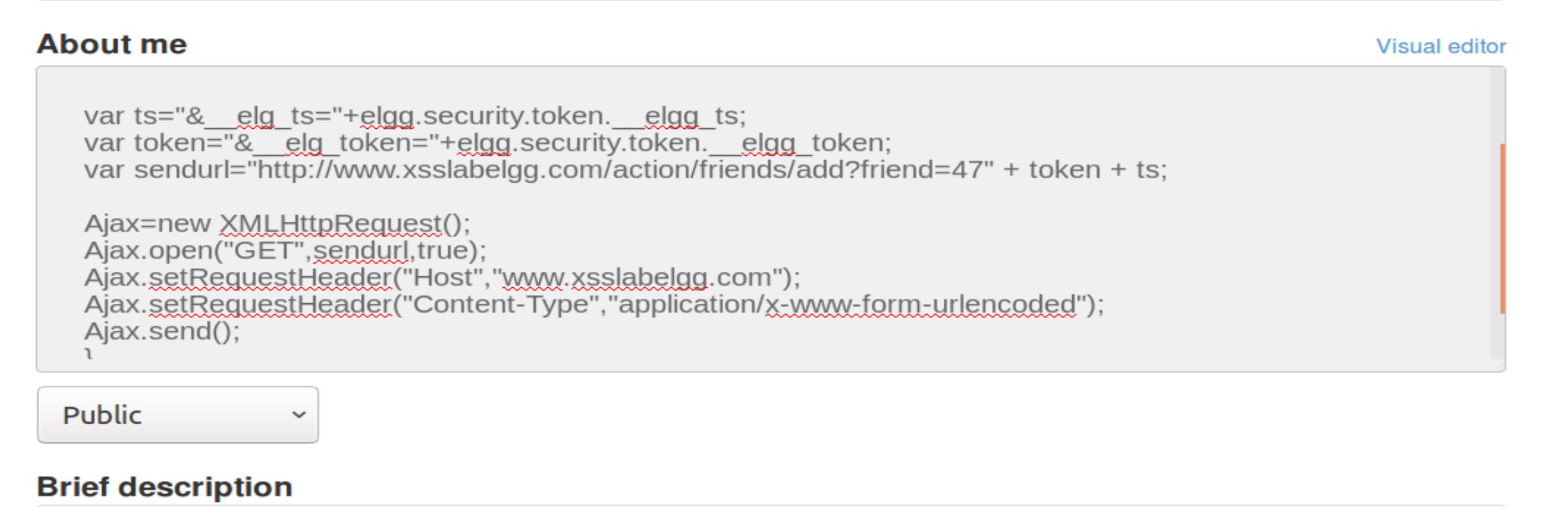

We can see, from boby’s profile, that we get a friend request without pressing the “add friend” button

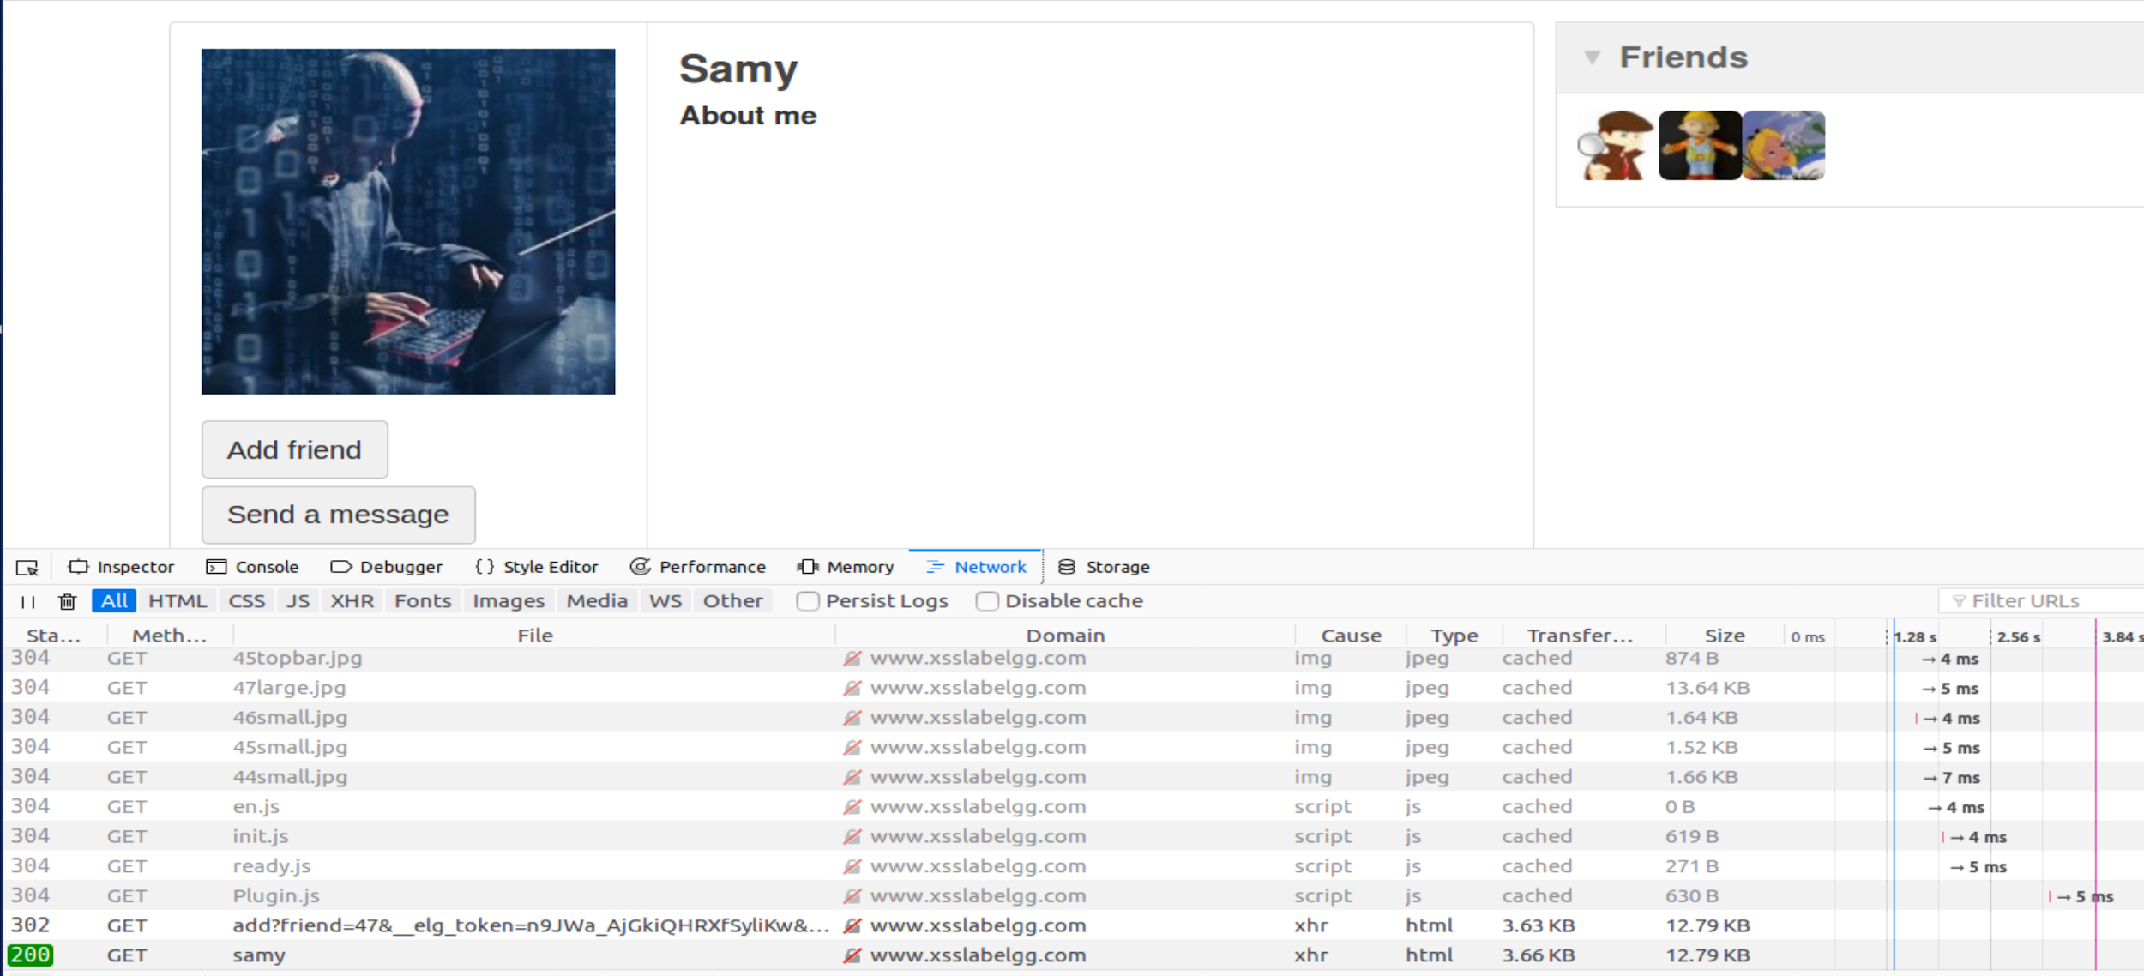

**Questions**

1. The site is using timestamp and a token for security purposes, ts is the timestamp and token is a security token, they are meant to prevent cross site request forgery attack.

But because the names of the variables are the same for every user, if we use the name of the variable, when the xss attack will run on some other user browser the value inside the variables will be the correct value, because it will run on the other user’s browser.

1. Yes we could still launch the attack but we will need to make sure that the code work after the encoding to html (we will need to change the way we write certain characters that HTML is changing, in a way that it will not change them, using %X , when x is a number that will match a certain ascii char in JS code like we saw in the lecture and more).

**Task 5: Modifying the Victim’s Profile**

We will edit boby’s profile through boby’s user to see how the post request is supose to look like.

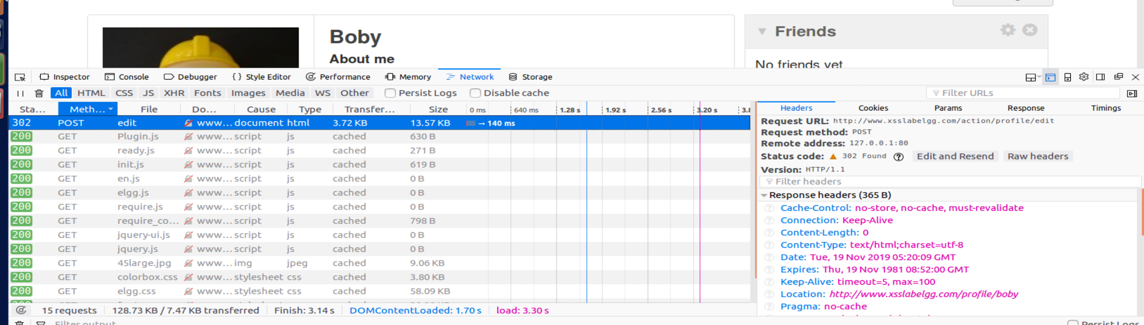

We will search for the parameters we need

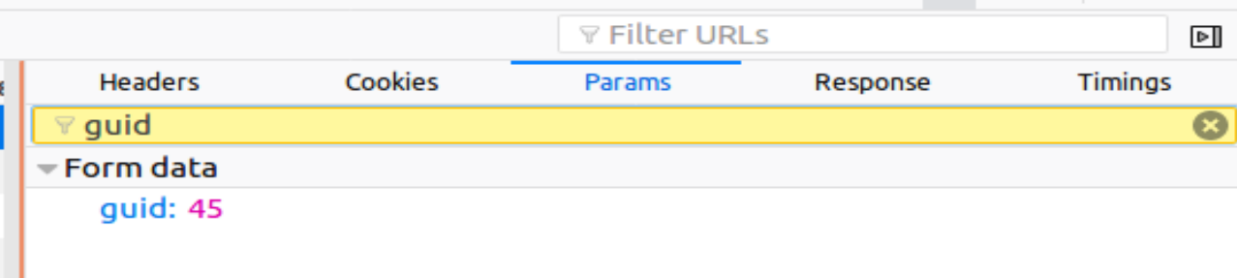

We will use 47, which is samy’s guid

We will add the code in the above me field

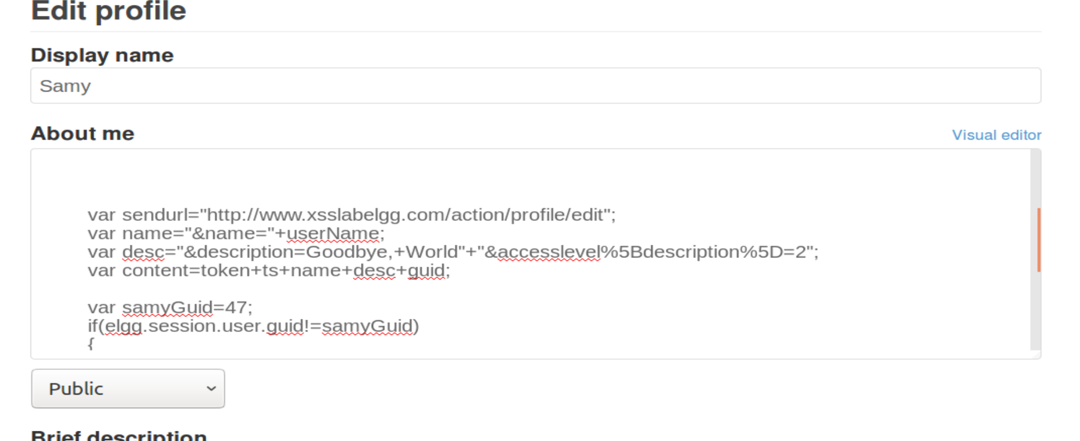

We will go the samy’s page with boby’s user

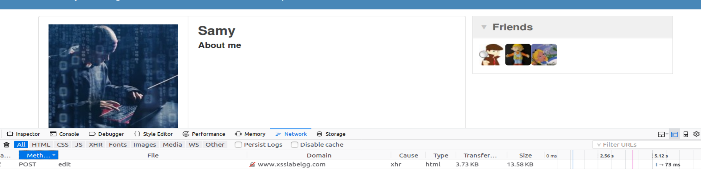

And indeed we changed boby’s about me

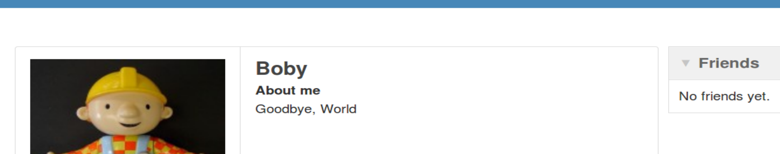

Question 3

This line is meant to prevent the xss attack from being executed when we are entering our own page.

If we won’t use this line, right after we edit the profile, our about me field will change to “Goodby, World”

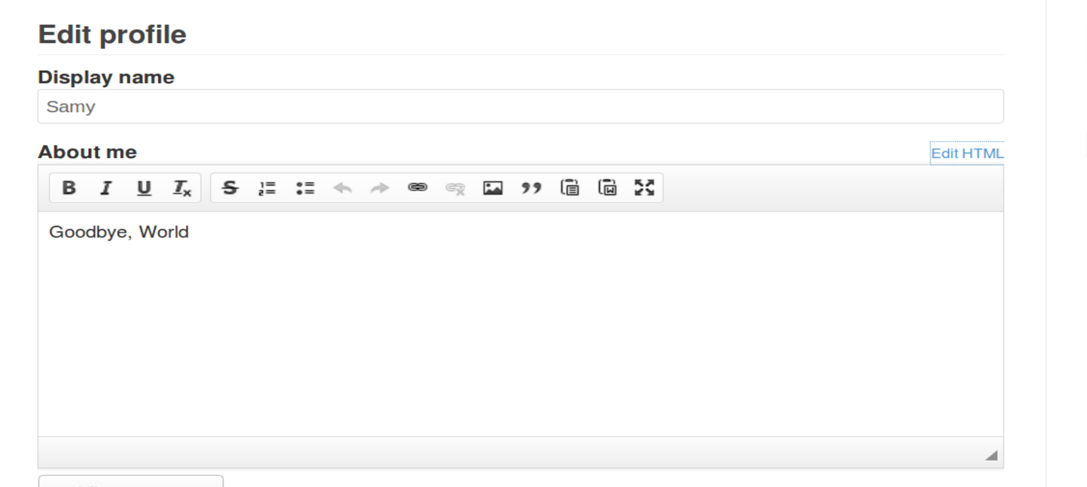

**Task 6: Writing a Self-Propagating XSS Worm**

We will write the worm code and “Goodbye, World”

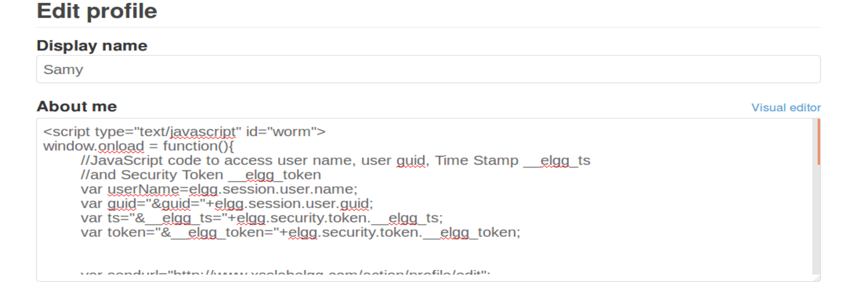

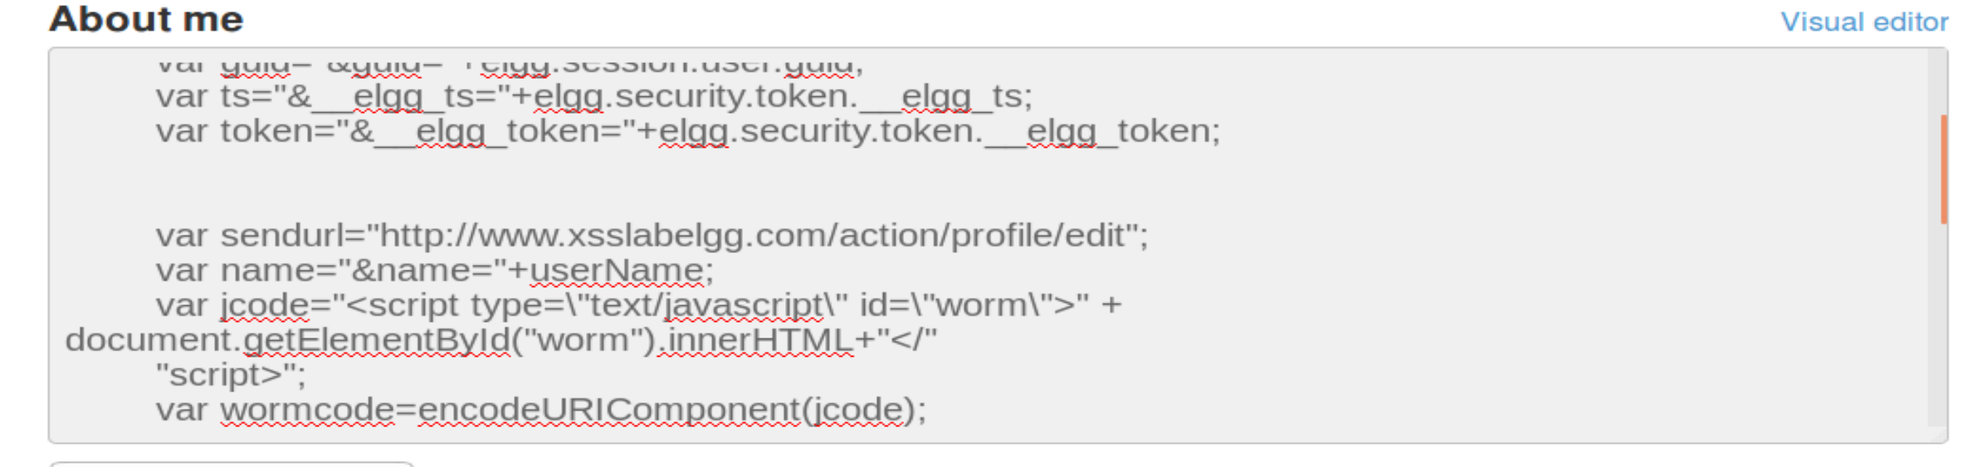

We will enter samy’s profile with alice’s user

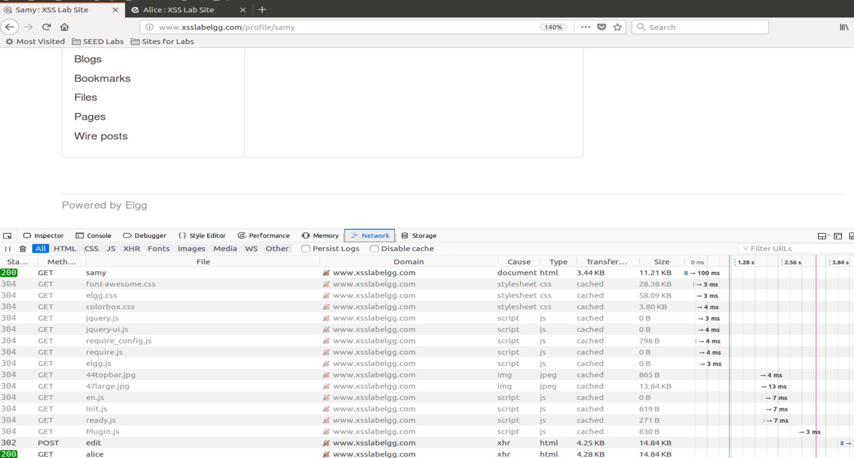

We can see that alice got the worm too

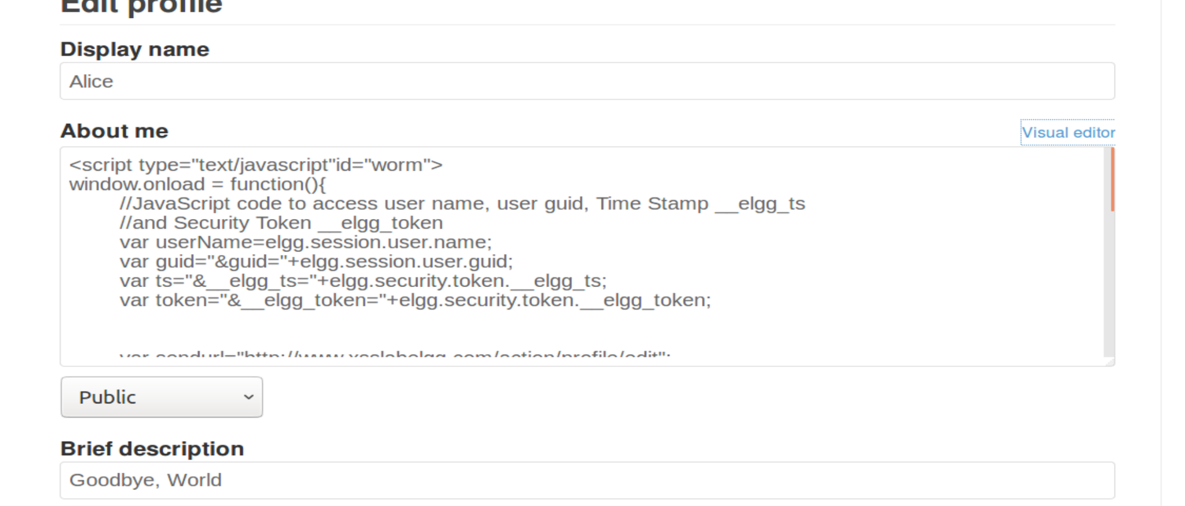

Now we will go to alice page with boby’s user and see that the worm propagates

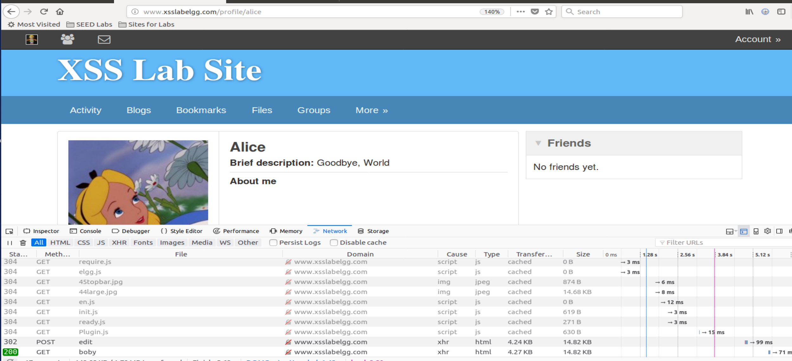

As we can see in the picture, we are in boby’s user (avatr in the upper left), and in Alice’s page

And we get the POST from alice which is the worm.

**Task 7: Countermeasures**

Activate the HTMLawed plugin

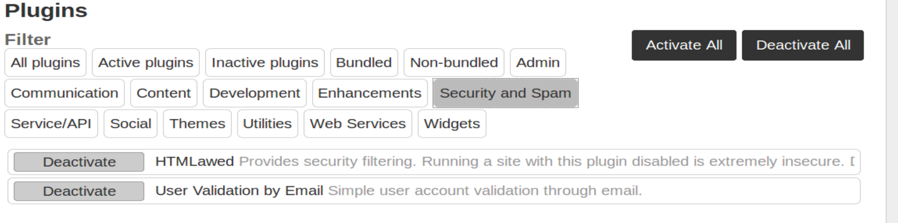

1. Now instead of running the code, we see the code

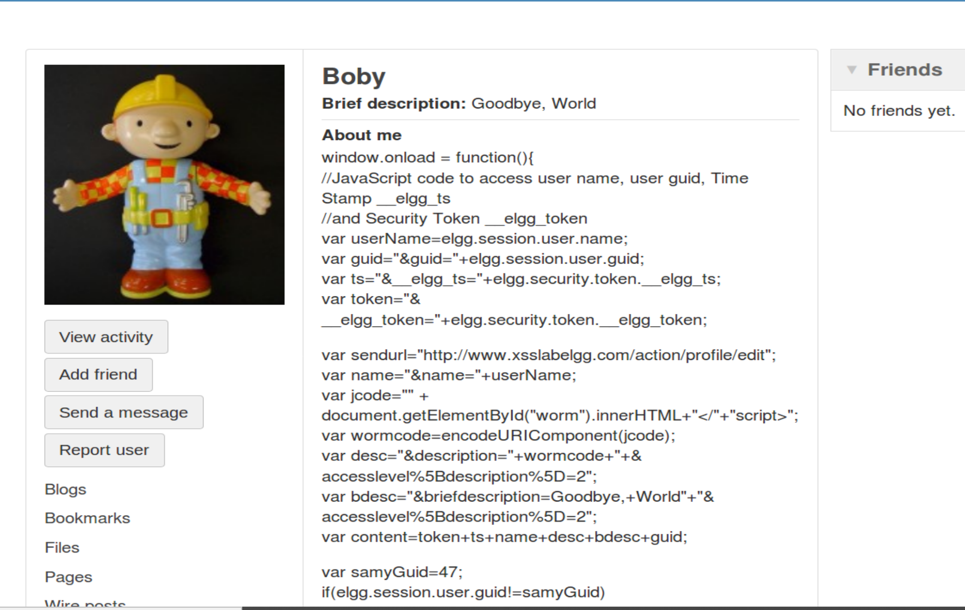

1. Activate the second countermeasure

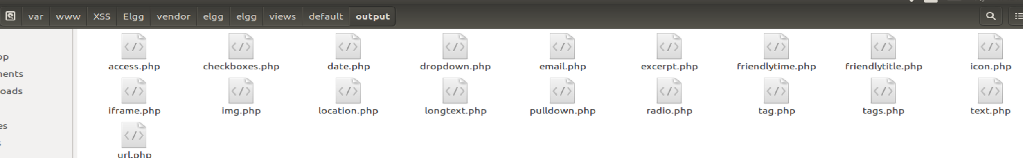

After editing the files we will restart the apache sever

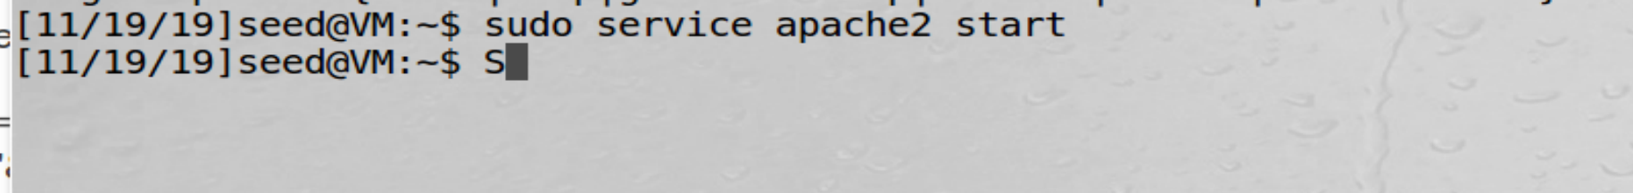

We will now look inside the profile of bob and see the code

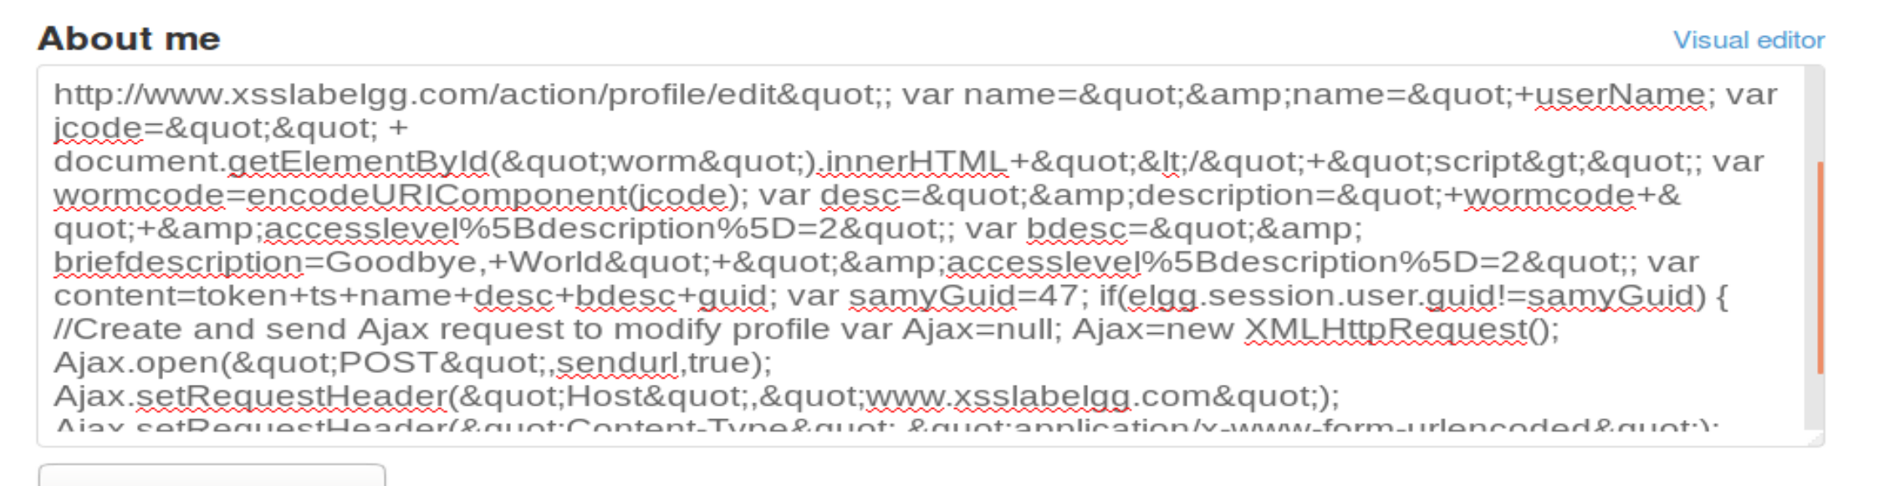

As we can see, the “htmlspecialchars” function has changed all sort of characters that we have written.

&quot instead of “ and &amp instead of & to prevent attacks such as xss